Microsoft Teams – Mobile Device Download (Android and iOS)

Before you start the installation process, please ensure that your device security is set for PIN entry. Your PIN needs to be 6 digits and cannot be sequential (123456) nor repeating (11111, 121212, etc.). Each device has a different way of setting this up; please check your device’s guide to do this.
You will be also asked to verify your HPL email address and password several times during installation.
A mobile device can either be a smart phone or a tablet (an iPad is a tablet).
- On your device, please go to Google Play or the App Store and download the Microsoft Teams app.

- Once downloaded, tap the app. You will be directed to a log in page. Tap “Sign in”. Please sign in with your HPL credentials (your HPL email address and your current password). Your device may default to the email address that your phone is signed into (e.g. a personal email address). If this is the case, please tap “Sign in with another account” at the bottom of the screen. After doing this, proceed to login in with your HPL email address and password.

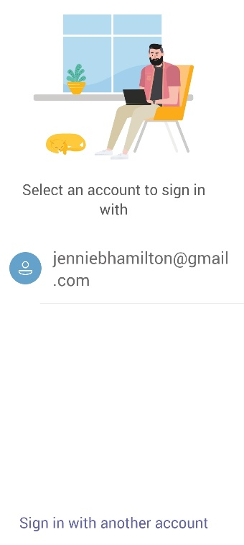
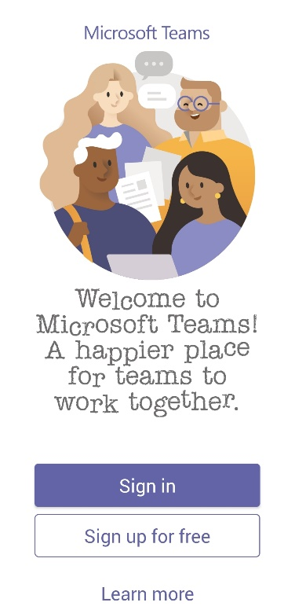

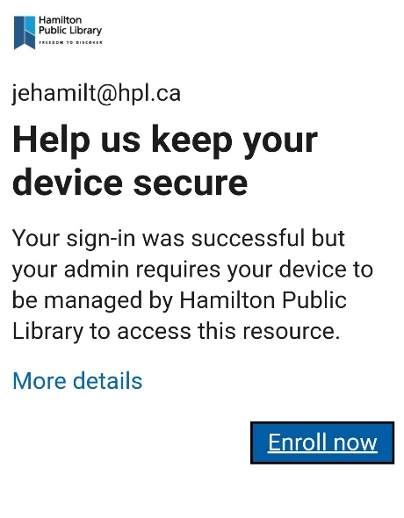
- If this is the first time you’re setting this up, you will get a message advising that your sign-in was successful but your admin requires your device to be managed by Hamilton Public Library to access this resource. To the right is a screenshot of that message. To proceed, tap “Enroll now”.

- You will then be directed to a page that will tell you to enrol your device using the Intune Company Portal app. This app ensures that you are still able to access company resources securely. This app allows the IT admin to manage specific functions on your device that is connected to work.

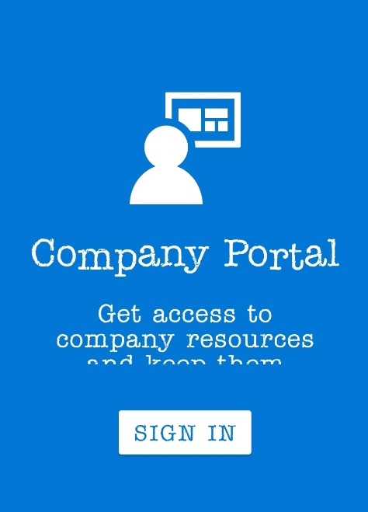
Tap “Get that App”. You will be redirected to the Intune Company Portal app page on Google Play or the App Store. Install the app.

- Once installed, Company Portal will ask you to sign in with your work credentials. Click “SIGN IN” and enter your HPL email address and password. Follow the steps below according to your type of device (Android or iOS).

For Android Devices:

- After signing in, you will see the Company Access Setup. Tap “Begin”.
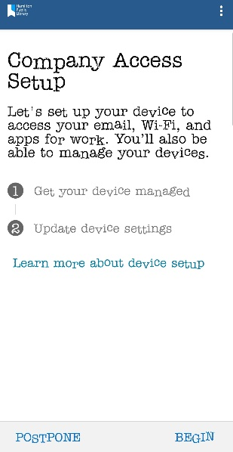

- The next screens explain what HPL can and cannot access on your phone by completing this installation.
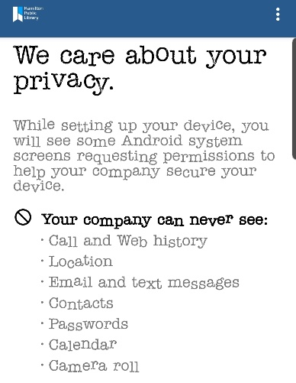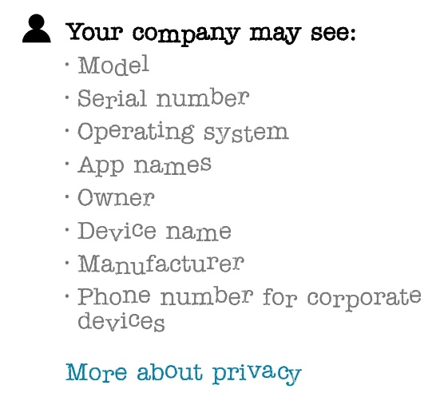

- You will also be asked to give the app permission to access phone calls, etc. You need to allow access or else installation will not proceed.
Activating the admin app will allow Company Portal to perform the following actions:
- Delete all data
- Change the screen lock
- Set password rules
- Monitor screen unlock attempts

- The next screen will ask you to Activate the app on your device. Tap Activate.

- The registration will begin. This process will take a few minutes (up to 10 mins sometimes).

- Once registration is finished, you will get to a page that looks like below. Tap on the Devices tab.
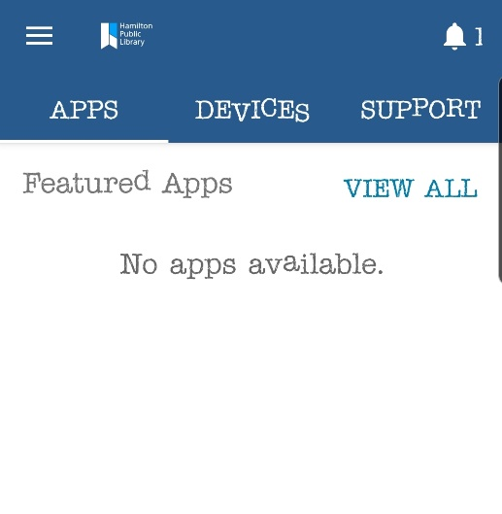

- You should see your device listed there. It will likely have a red exclamation mark beside it. Tap on your device.
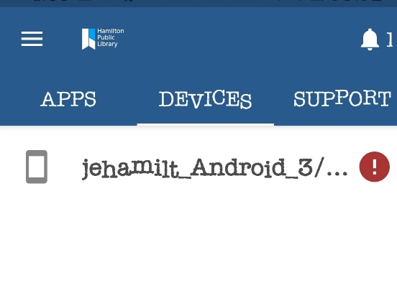

- It will take you to the Device details page where you will find a list of issues that would need to be addressed before enrolment can be completed. Example: your phone PIN is not set up.
Tapping on the alert will take you to the Update Device Settings page, where you will find more details regarding the error. As you resolve the issue, tap the Confirm Device Settings link at the bottom. Flagged errors should disappear as they are resolved.

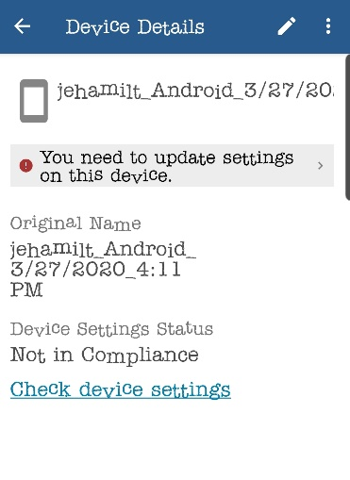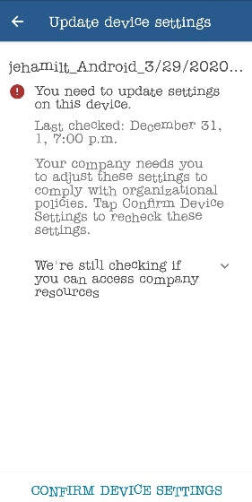

- After resolving the errors, you might get a persistent error message at this point that it looks like it’s not getting resolved. Don’t worry; going to the Company Portal settings will resolve this. On the main page of Company Portal, tap on the hamburger menu on the upper left (three horizontal lines). A fly out menu will come from the left.
Tap “Settings” and scroll down to “Security Policy” and tap “Sync”.
This should resolve the error. Go back to Device details and tap Confirm Device Settings there. Don’t worry if it doesn’t clear the error.
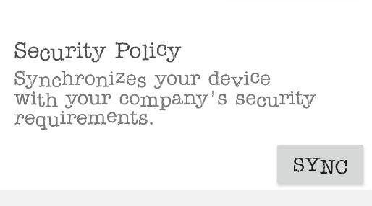
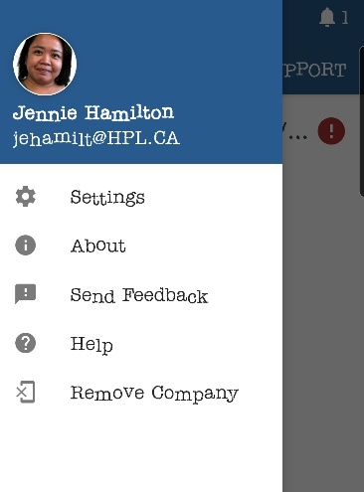

NOTE: Depending on your device, after the device’s settings are confirmed, you might be asked to enter your HPL logins again within the Intune Company Portal app. When you enter and confirm your credentials, it is possible for your Outlook email and calendar to sync with your device’s Email and Calendar. If you don’t want to do this, don’t enter your credentials.
- At this point, you can go to the Microsoft Teams App and log in. If device authorization was done properly, you will then be logged into your Microsoft Teams account.

For iOS devices:

- Once you’ve downloaded the Intune Company Portal app, you will get to a sign in page. Enter your HPL email address and password.

- The next page will be the Set Up page. Tap “Begin” at the bottom.
- The next few pages will be information on what HPL can and cannot see or do on your device. Tap “Continue” at the bottom.
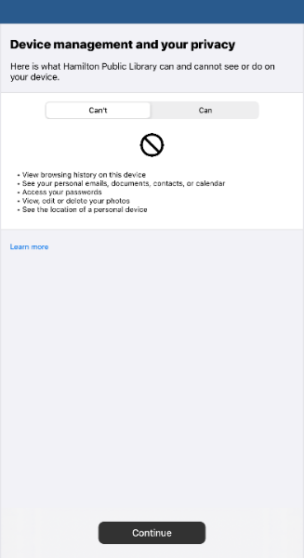

- You will be prompted to download management profile. Tap “Allow”.

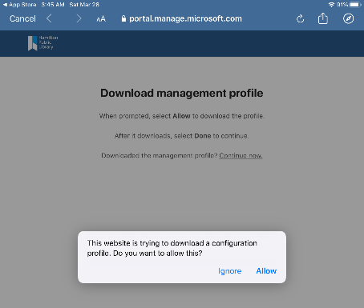

- The next screen provides instructions on how to install the Management Profile. You will need to go to the Settings app on your device in order to follow these instructions. Click “Profile Downloaded” (which should be close to the top of your Settings app). Install the profile.

- Once everything is done correctly, you will get to the page below. Tap “Done”.
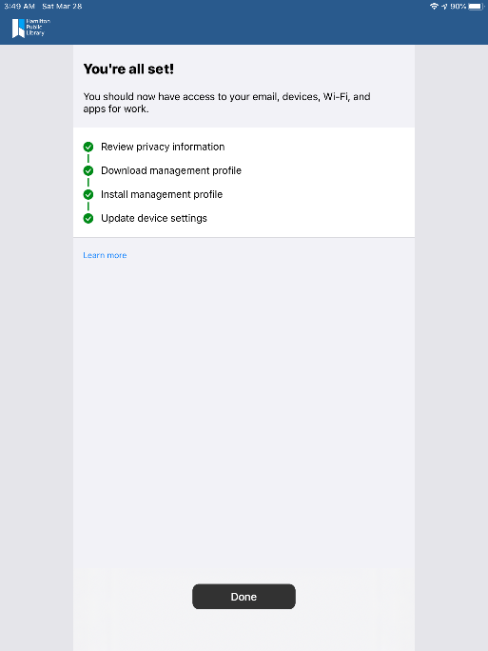

- Go to the Microsoft Teams app and log in using your HPL email and password.

