Microsoft Teams – Desktop/Laptop Download Instructions (Windows and Mac)

TO GET STARTED FOR ALL DEVICES

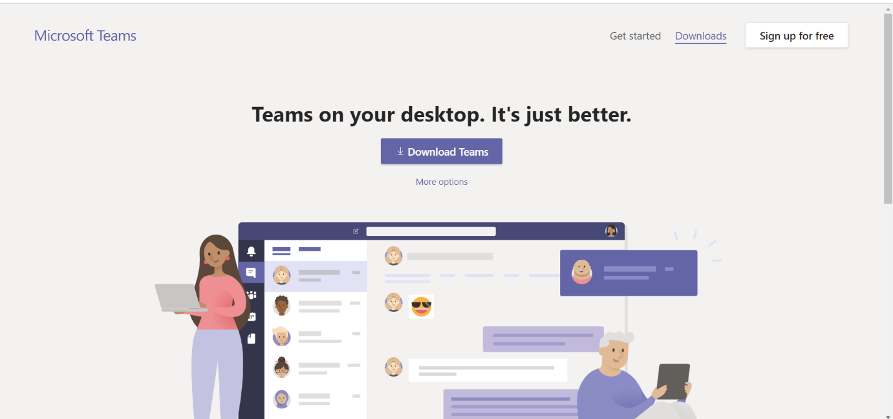
- Using a browser, go to https://teams.microsoft.com/download

- Scroll down to get to the list of download file options. If you have a Windows computer, follow the steps in this document under the “WINDOWS” heading below. If you have a Mac computer, jump to the steps in this document under the “MAC” heading below.

WINDOWS INSTRUCTIONS

- Before you click on the appropriate file for your computer, ensure you know where files are downloaded on your computer. For example, files are often downloaded to your Downloads folder. They may also show up in your browser at the bottom temporarily. If you’re unsure how to access downloaded files, contact the Service Desk.

- Click on one of the two Windows download options according to your computer. If you are not sure which option to choose, contact the Service Desk.

- Once you click on a download option, the setup.exe file will download. Once the download is finished, click on the set-up file (you may have to go to your Downloads folder to access the file if it doesn’t pop up in the browser) and the installation process should begin.

- When installation is finished, a log in page should appear. Enter your work email address and the password you use to sign in to a computer at work.

- A successful log in will open the app on your desktop.

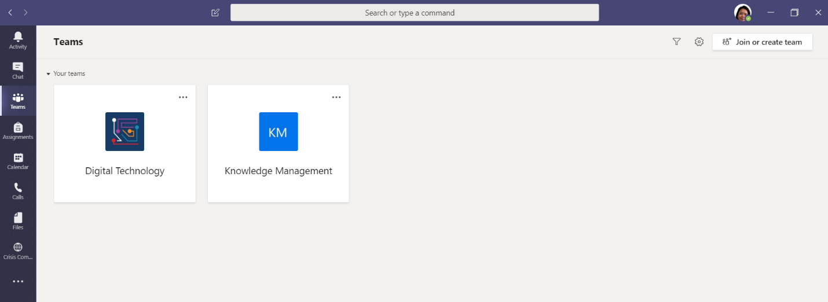

- The Microsoft Teams desktop app should create a shortcut on your desktop after installation.

MAC INSTRUCTIONS
Mac users can install Teams by using a PKG installation file for macOS computers. Administrative access is required to install the Mac client. The Mac version of Teams is installed to the /Applications folder.
- Click on the “Mac” download file option. The PKG file will start to download.

- Once the PKG file has downloaded, double-click it to start the installation.
- Follow the installation wizard to complete the installation. During the installation, the PKG will prompt for admin credentials. The user needs to enter the admin credentials, regardless of whether or not the user is an admin.
- Teams will be installed to /Applications folder. It is a machine-wide installation.

